CAR ACCIDENT SQL AND POWER BI PROJECT.
Key performance indicators .

SELECT SUM(number_of_casualties) AS CY_Casualties
FROM road_accident
WHERE YEAR(accident_date)= '2022'

-- CY CASUALTIES IN 2022
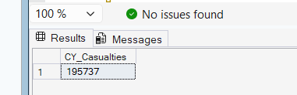

CY Accidents

SELECT COUNT(*) AS Accidents_2022
FROM road_accident
WHERE accident_date >= '2022-01-01'
AND accident_date < '2023-01-01';

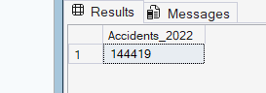

Fatal Casualties

SELECT SUM(number_of_casualties) AS Fatal_Casualties_2022
FROM road_accident
WHERE accident_severity = 'Fatal'
AND accident_date >= '2022-01-01'
AND accident_date < '2023-01-01'

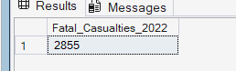

Note : From here down i’ve decided to take the whole screenshot together

Serious Casualties

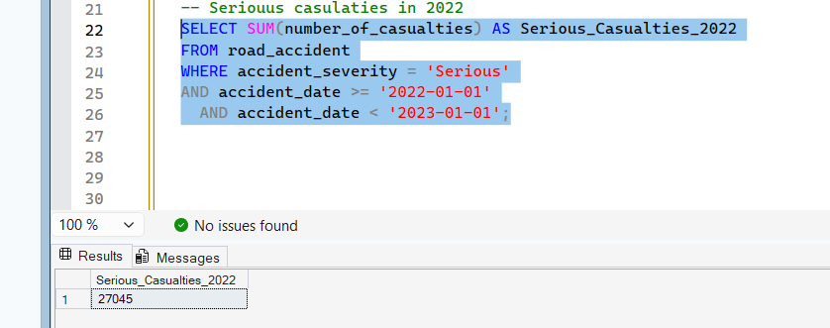

CY SLIGHT CASUALTIES

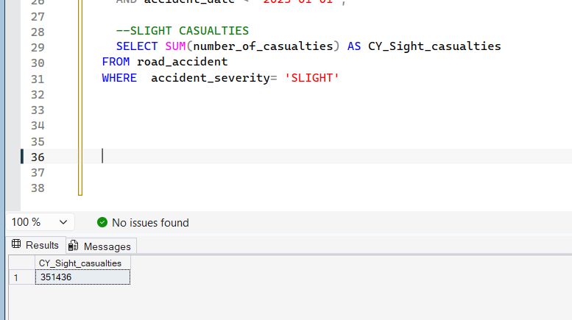

— SLIGHT PERCENTAGE IN 2022

SELECT
SUM(CASE WHEN casualty_severity = 3 THEN 1 ELSE 0 END) * 100.0
/ COUNT(*) AS slight_percentage
FROM Accidents;
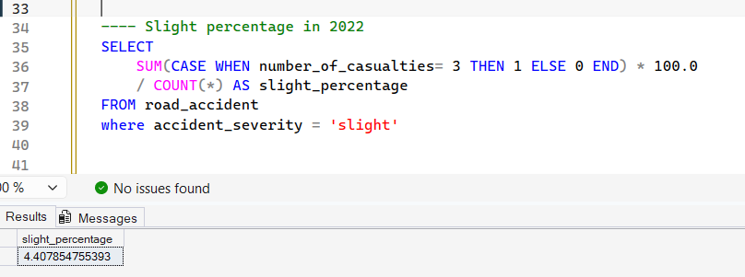

SELECT CASUALTIES BY VEHICLE TYPE ( GROUPS )
Note : Select statements had to be used in the group order we’ve created earlier on power BI

SELECT
CASE
WHEN vehicle_type LIKE '%Agricultural%' THEN 'Agricultural'
WHEN vehicle_type LIKE '%Motorcycle%'
OR vehicle_type LIKE '%Bike%'
OR vehicle_type LIKE '%Scooter%' THEN 'Bike'
WHEN vehicle_type LIKE '%Bus%' OR vehicle_type LIKE '%Coach%' THEN 'Bus'
WHEN vehicle_type LIKE '%Car%' OR vehicle_type LIKE '%Taxi%' THEN 'Car'
WHEN vehicle_type LIKE '%Van%' THEN 'Van'
ELSE 'Other'
END AS vehicle_group,

SUM(number_of_casualties) AS total_casualties

FROM road_accident
GROUP BY
CASE
WHEN vehicle_type LIKE '%Agricultural%' THEN 'Agricultural'
WHEN vehicle_type LIKE '%Motorcycle%'
OR vehicle_type LIKE '%Bike%'
OR vehicle_type LIKE '%Scooter%' THEN 'Bike'
WHEN vehicle_type LIKE '%Bus%' OR vehicle_type LIKE '%Coach%' THEN 'Bus'
WHEN vehicle_type LIKE '%Car%' OR vehicle_type LIKE '%Taxi%' THEN 'Car'
WHEN vehicle_type LIKE '%Van%' THEN 'Van'
ELSE 'Other'
END

ORDER BY total_casualties DESC;

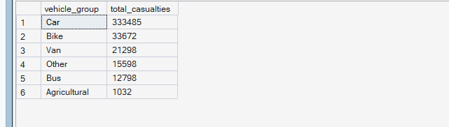

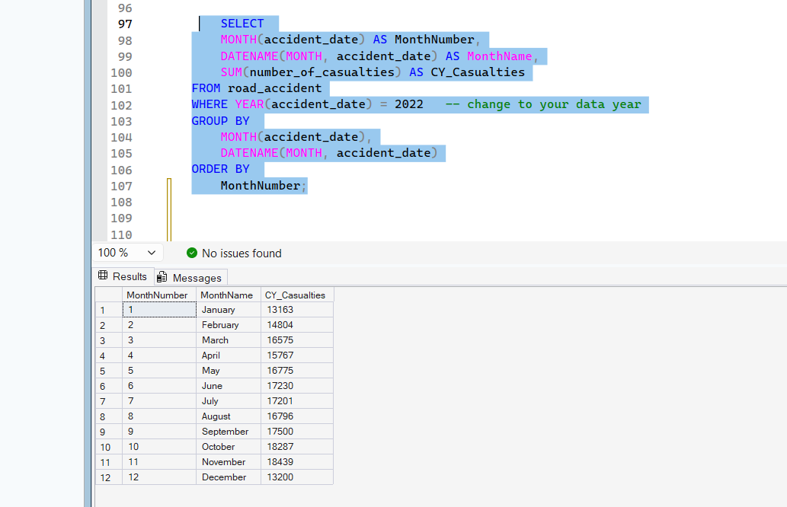
Above / KPI CY Casualties by months

Kpi Casualties by road type

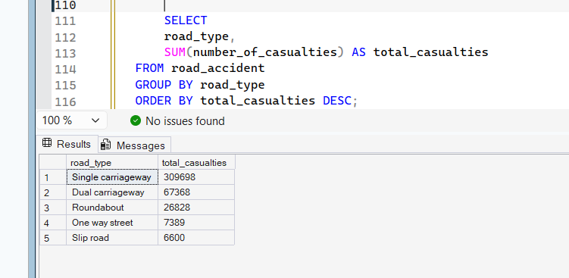

— kpi Casualties by urban or rural areas

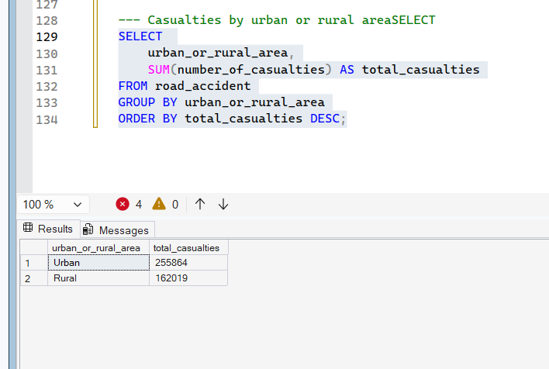

With Percentage %% 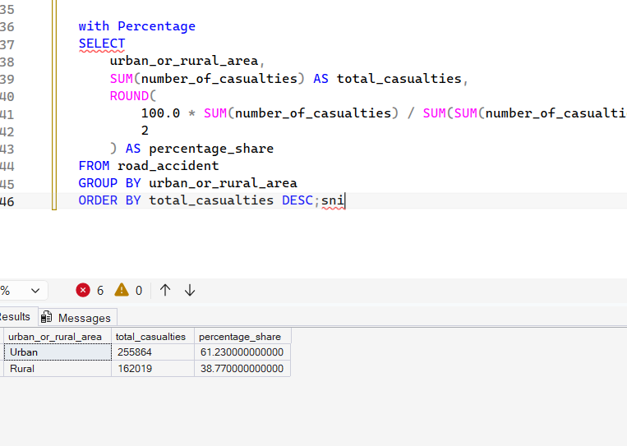

Kpi Casualties By LIGHT Conditions

KPI top 10 places by casualties
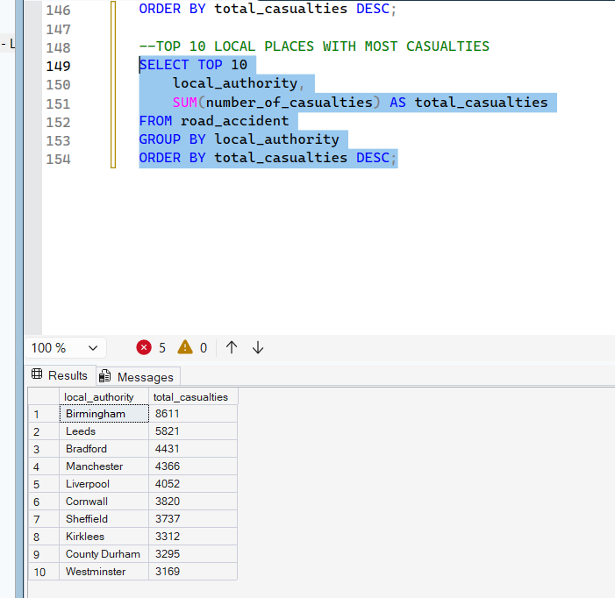

Insights Great dataset!

Column | Type | Notes
accident_index | string | Unique ID per accident
accident_date, time | string | 2 years of data, 730 unique dates
accident_severity | string | Slight / Serious / Fatal
number_of_casualties | int | 1–48, avg 1.36
number_of_vehicles | int | Numeric
vehicle_type | string | 15 types, 78% are Cars
weather_conditions | string | 8 categories
road_type | string | Single carriageway dominates
speed_limit | int | 10–70 mph
light_conditions | string | Daylight vs darkness types
urban_or_rural_area | string | 64% Urban, 36% Rural
day_of_week | string | Friday has most accidents
local_authority, police_force | string | Geographic grouping

Interesting angles worth exploring:
- Friday has the most accidents (~50k) — could signal rush-hour/weekend effect
- 74% of accidents happen in daylight, but darkness accidents may have higher severity (worth a query)
- Fatal accidents are only 1.3% of total — good for a CASE WHEN severity classification
- Speed limit 30 has by far the most accidents (200k) simply due to volume of 30mph roads

